Create a VPC with Public & Private Subnets and Launch an EC2 Instance
Objective
To create a custom Virtual Private Cloud (VPC) with both public and private subnets, attach an Internet Gateway, configure routing, and launch a Linux EC2 instance in the public subnet.
Step 1: Create VPC
- Navigate to VPC → Your VPCs → Create VPC
- Choose VPC only
- IPv4 CIDR block: 10.0.0.0/16
- Tenancy: Default
- Click Create VPC
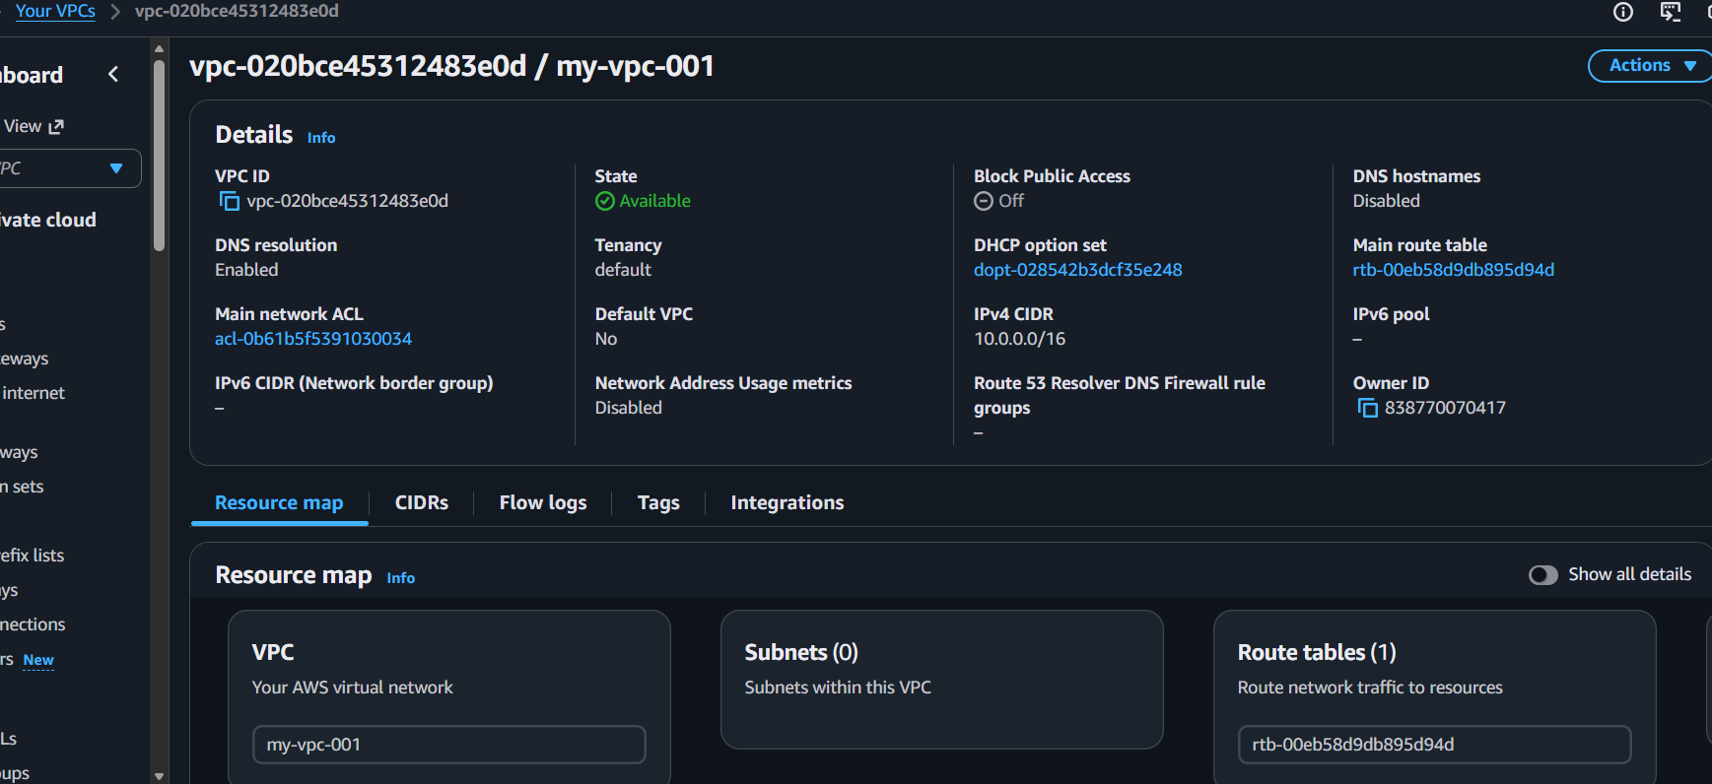
Step 2: Create an Internet Gateway and Attach to VPC
- In the VPC Dashboard, go to Internet Gateways → Create Internet Gateway
- Click Create Internet Gateway
- After creation, select it and choose Actions → Attach to VPC → Select created VPC
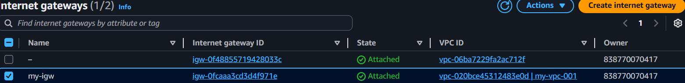
Step 3: Create Subnets
- Create Public Subnet
  - Choose VPC
  - Subnet name: Public-Subnet
  - Choose Availability Zone
  - IPv4 CIDR block: 10.0.1.0/24
  - Click Create Subnet

- Create Public Subnet
  - Choose VPC
  - Subnet name: Private-Subnet
  - Choose Availability Zone
  - IPv4 CIDR block: 10.0.1.0/24
  - Click Create Subnet
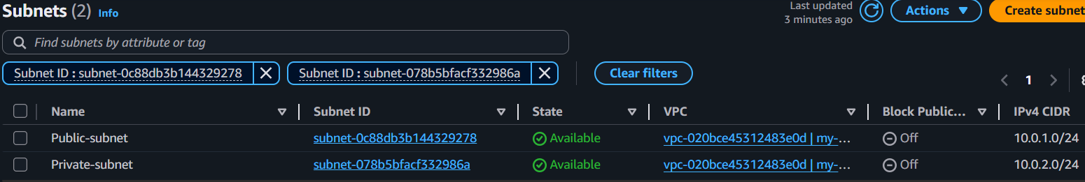
Step 3: Configure Route Tables
- Public Route Table
- Go to Route Tables → Create Route Table
  - Name
  - Select VPC
  - Click Create
- Select the route table → Go to Routes → Edit routes
  - Add Route
  - Destination: 0.0.0.0/0
  - Target Internet Gateway → Select the Internet Gateway
  - Click Save Changes
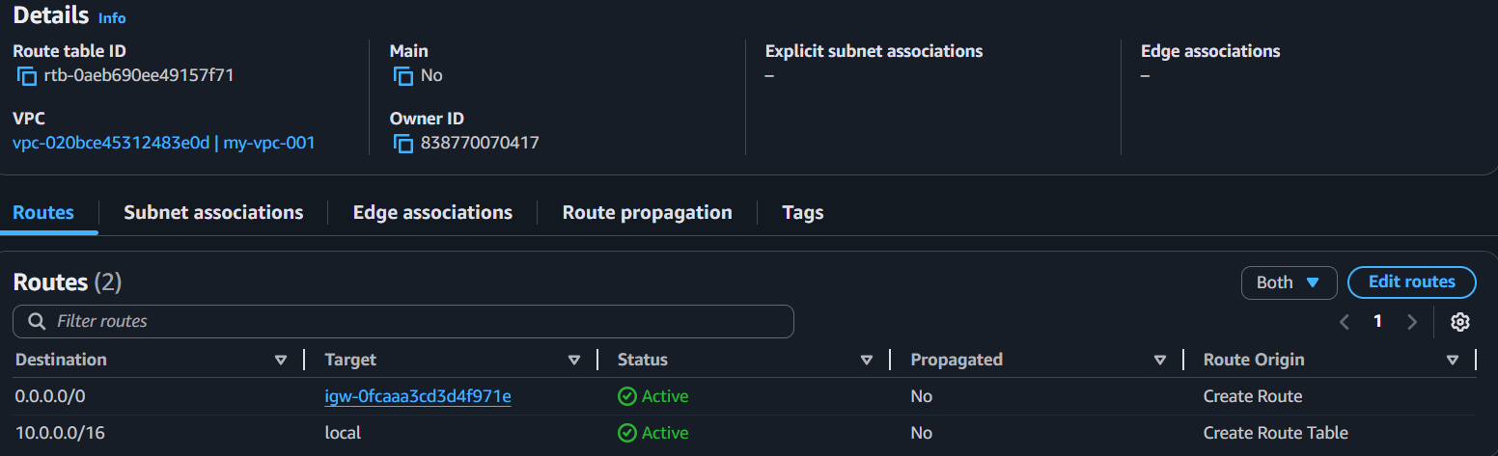
- Now associate it with the Public Subnet
  - Go to Subnet associations → Edit subnet associations
  - Select PublicSubnet
  - Save
Public Subnet connected to the Internet
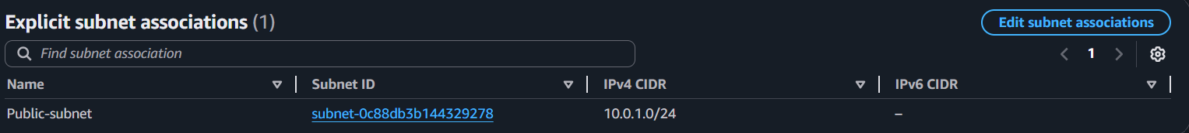
- Private Route Table
- Create another private route table
- Subnet association with Private-Subnet
- Do not add Internet Gateway route
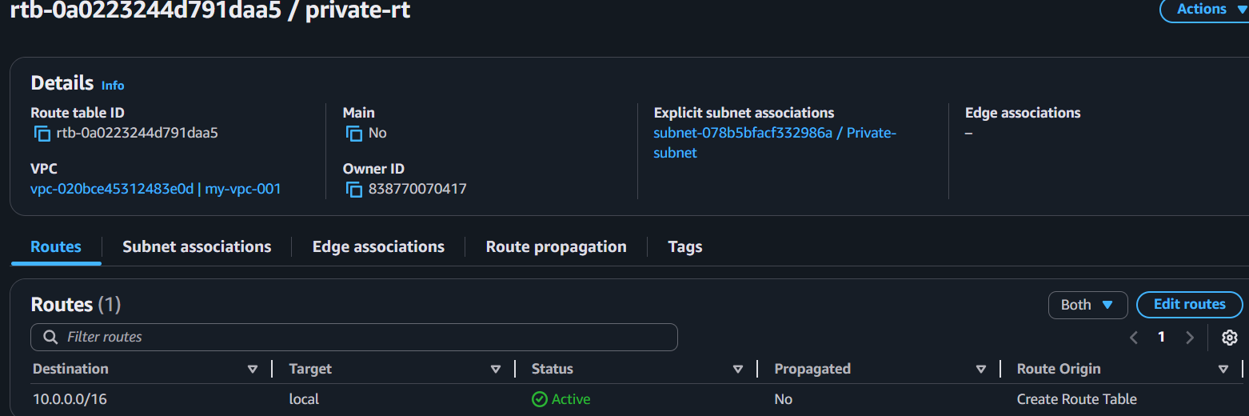
Step 4: Launch an EC2 Instance in Public Subnet
- Go to EC2 → Instances → Launch instance
- Name: my-public-ec2
- AMI: Ubuntu
- Instance type: t2.micro
- Choose Key pair
- Network settings:
  - Choose created VPC
  - Subnet Public
  - Auto-assign public IP: Enabled
  - Security group: Create new → allow:
  - SSH (22) from My IP
  - HTTP (80) from Anywhere
- Click Launch Instance
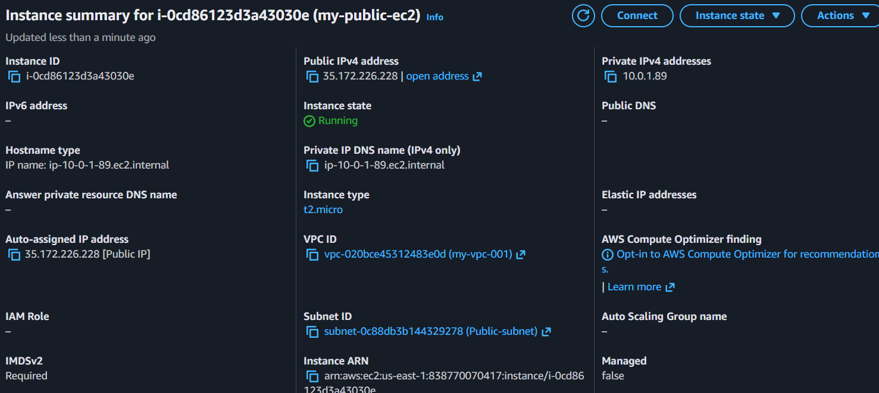
Step 5: Connect to Your EC2 Instance
